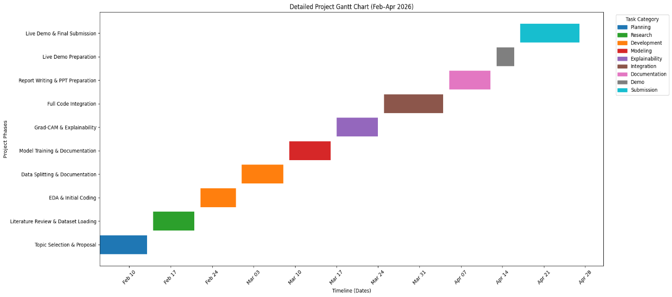
Phase | Dates | Duration
Topic Selection & Proposal | Feb 9 – Feb 15 | 1 week
Literature Review & Dataset Loading | Feb 16 – Feb 22 | 1 week
EDA & Initial Coding | Feb 23 – Feb 29 | 1 week
Data Splitting & Documentation | Mar 1 – Mar 7 | 1 week
Model Training & Documentation | Mar 8 – Mar 14 | 1 week
Grad-CAM & Explainability | Mar 15 – Mar 21 | 1 week
Full Code Integration | Mar 22 – Mar 31 | ~1.5 weeks
Report Writing & PPT Preparation | Apr 1 – Apr 8 | 1 week
Live Demo Preparation | Apr 9 – Apr 14 | 5–6 days
Final Demo & Submission | Apr 15 – Apr 28 | ~2 weeks

Project Workflow: Explainable Deep Learning for Brain Tumour Classification in MRI Images using Grad-CAM
- Data Acquisition
MRI brain images are collected from publicly available datasets such as Kaggle, Figshare, or BraTS. The dataset is organized into four classes: glioma tumour, meningioma tumour, pituitary tumour, and no tumour.
- Data Pre-processing
All MRI images are resized to a fixed resolution suitable for the convolutional neural network (for example 224 × 224). Pixel values are normalized to improve learning stability. Data augmentation techniques such as rotation, flipping, zooming, and brightness adjustment are applied to increase dataset diversity and reduce overfitting.
- Dataset Splitting
The dataset is divided into training, validation, and testing sets. Typically 70 percent of data is used for training, 15 percent for validation, and 15 percent for testing.
- Model Development
A transfer learning convolutional neural network such as ResNet50, VGG16, or EfficientNet is selected. The final classification layer is replaced with a new fully connected layer matching the number of tumour classes. The model is compiled using categorical cross-entropy loss, Adam optimizer, and evaluation metrics such as accuracy, precision, recall, and F1-score.
- Model Training
The model is trained for multiple epochs using the training dataset. Validation data is monitored to avoid overfitting. Early stopping and model checkpointing techniques are used to save the best performing model.
- Model Evaluation
The trained model is evaluated using the test dataset. Performance metrics include confusion matrix, classification report, ROC curve, and AUC score to measure classification effectiveness.
- Explainability using Grad-CAM
Grad-CAM is applied to the last convolutional layer of the trained network. Gradients are computed to identify important regions influencing the prediction. A heatmap is generated and overlaid on the original MRI image to highlight the tumour region responsible for the decision.
- Result Analysis
The highlighted regions are compared with the actual tumour locations to verify whether the model focuses on medically relevant areas. This step validates the trustworthiness of the deep learning model.
- System Integration
An end-to-end pipeline is created where an input MRI image is preprocessed, classified by the model, and visualized using Grad-CAM to display both prediction and explanation.
- Documentation and Visualization
Training curves, evaluation tables, and Grad-CAM visualizations are prepared and included in the dissertation and presentation to demonstrate the effectiveness of the proposed explainable AI framework.

